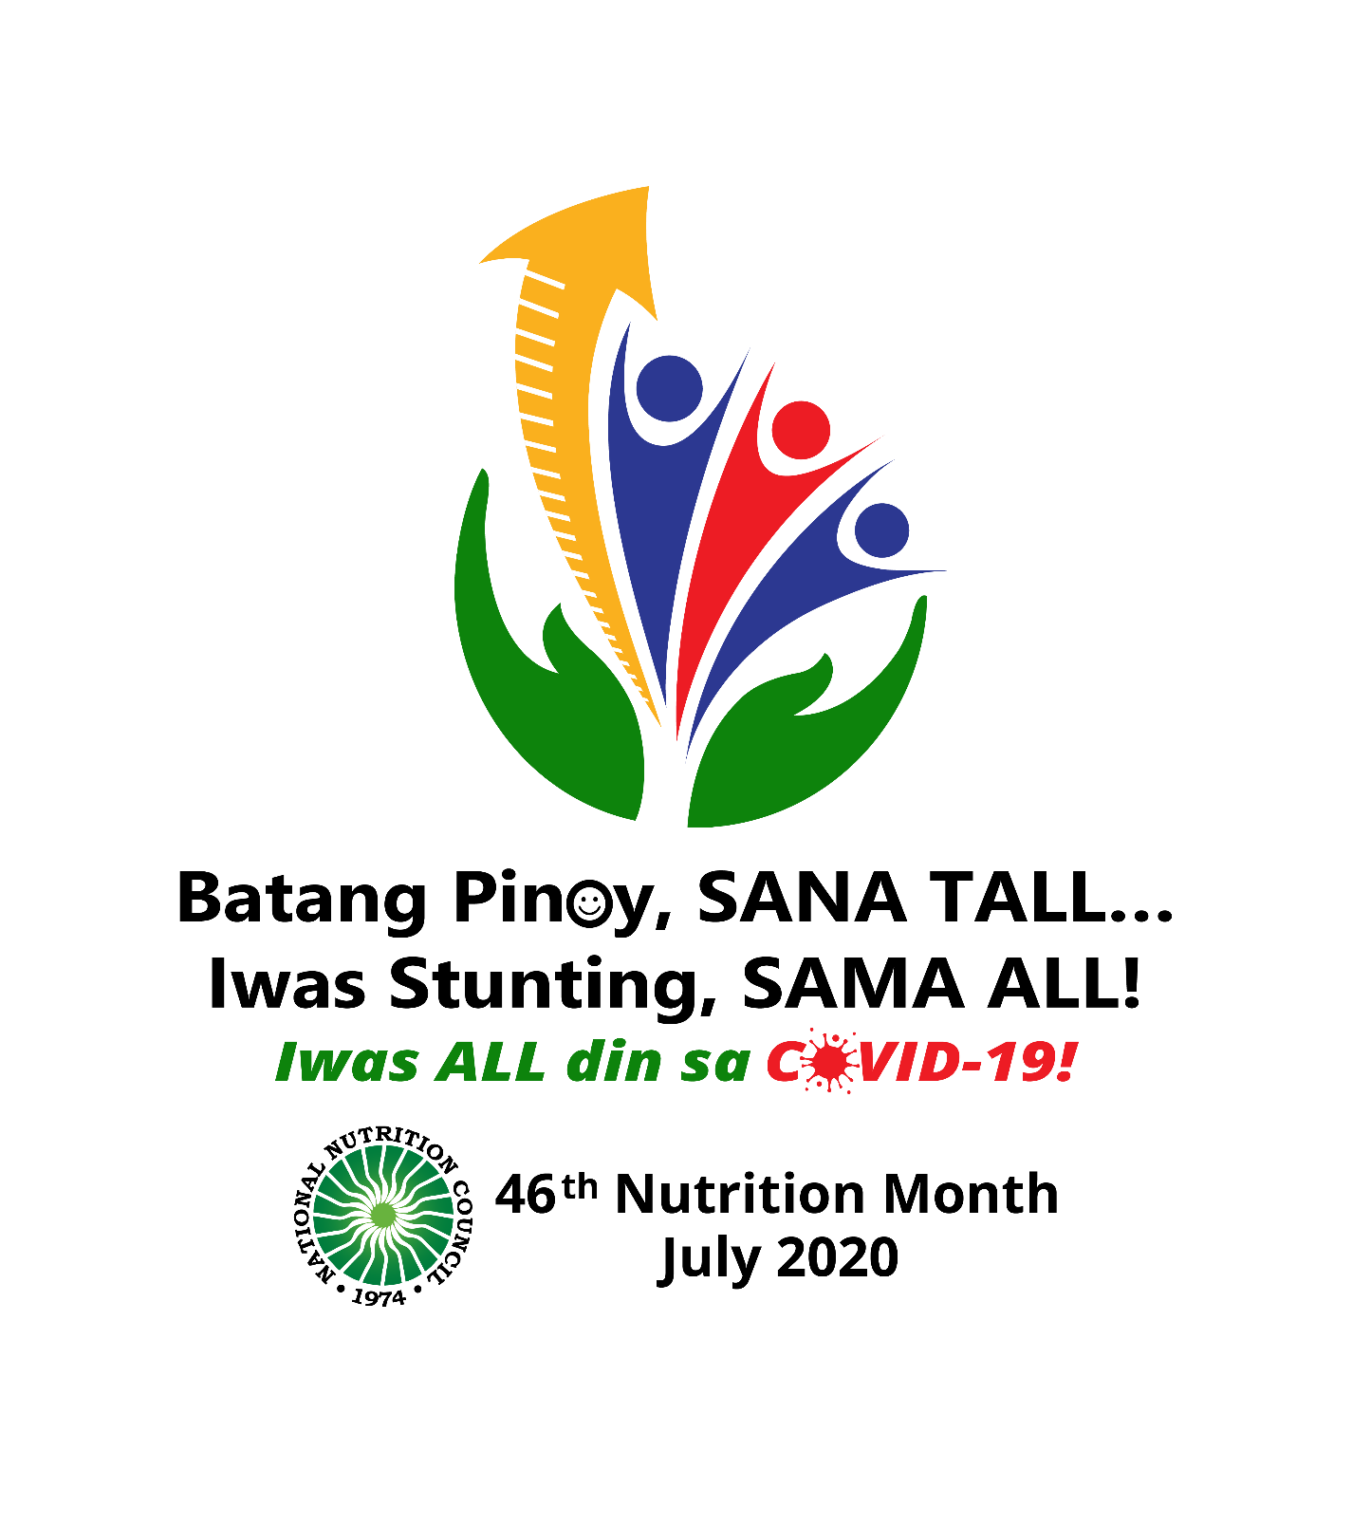

**TALKING POINTS**

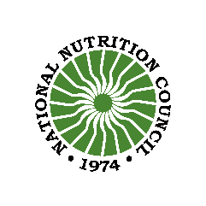****

**National Nutrition Council**

Email: [info@nnc.gov.ph](mailto:info@nnc.gov.ph)

Website: [www.nnc.gov.ph](http://www.nnc.gov.ph)

FB: NNCOfficial, First 1000 Days PH

Twitter: @nncofficialph

**Table of Contents**

1. The 46th Nutrition Month 2
2. What is stunting? 2
3. How to interpret stunting 3
4. Stunting is a crisis 3
5. Are Filipino children short because Filipinos are naturally short? 5
6. The situation on stunting 5
7. Stunting reduction 6
8. What drives stunting in the Philippines? 8
9. What do we aim for in stunting? 9
10. What have been done to address stunting? 11
11. What can stakeholders do to support efforts to reduce stunting? 15
12. How does the COVID-19 pandemic affect stunting reduction efforts? 17
13. What are suggested activities to support the Nutrition Month campaign? 17
14. Citations 18

# **The 46th Nutrition Month**

The National Nutrition Council, the policy making and coordinating agency on nutrition, calls on everyone to participate in the 46th Nutrition Month campaign. For this year, the focus is on catalyzing actions to address child stunting. The theme “**Batang Pinoy, SANA TALL… Iwas stunting, SAMA ALL!**” expresses the aspiration of Filipino families to have children who are able to achieve their fullest potential and this can be achieved when we all work together.

The sub theme “**Iwas ALL din sa COVID-19.**” is added considering the pandemic and the community quarantine still in effect. It becomes more imperative to ensure nutrition among Filipinos to improve resilience against disease and minimize the long-term effects of malnutrition.

The Nutrition Month logo represents the goal of having taller children (ruled arrow) and this is nurtured by proper care and nutrition (hands at the bottom) with focus on the first 1000 days (the arrow and the three heads).

The campaign aims to catalyze actions to:

1. raise awareness on the impact of stunting and evidence-based solutions among families and communities leading to change in behaviors to prevent stunting;
2. stimulate national and local (including communities) discourse on stunting to understand its causes and the multi-sectoral solutions for increased investments in interventions; and
3. generate concrete commitment among various stakeholders to scale-up nutrition actions.

While July is designated as Nutrition Month, actions to achieve the objectives are expected to be sustained throughout the year.

# **What is stunting?**

Stunting or being too short for one’s age indicates undernutrition in a child who is not receiving enough nutrition to grow and develop to reach his or her full potential. **Stunting or linear growth failure** is defined as the percentage of children aged 0 to 59 months (under 5 years old) whose height for age is below -2 standard deviations (moderate and severe stunting) and -3 standard deviations (severe stunting) from the median of the World Health Organization (WHO) Child Growth Standards [1, 2].

Based on the WHO Child Growth Standards, the median height for boys at age 5 is 110 cm, while for girls is 109.4 cm. There is moderate to severe stunting for girls at age 5 when their height is between 99.9 cm to 95.2 cm. Severe stunting occurs if the height is below 95.2 cm. For boys, moderate stunting occurs when their height at age 5 is between 100.7 to 96.1 cm. Height less than 96.1 cm. indicates severe stunting for boys.

# **How to interpret stunting**

The percentage of children who are stunted reflects the cumulative effects of undernutrition and infections since and even before birth. The measure can be interpreted as an indication of poor environmental conditions or long-term restriction of a child’s growth potential. Stunting reflects long-term outcomes, such as frequent and high disease burden, limited access to food supply, poor feeding practices and/or low household economic status in a population.

A decrease in stunting rates is a long-term indicator that social development is spread among the poor and the wealthy. Stunting as an indicator is best for use in evaluation and not for monitoring as it does not change much in the short term. Information on an individual child’s stature is useful as an aid to diagnosis.

Data on stunting is generated from the national nutrition surveys which is used for planning and evaluation. Local government units also generate data on stunting among preschool children for use in identifying targets for interventions as well as for planning and evaluation.

# **Stunting is a crisis**

According to the WHO, childhood stunting is “one of the most significant impediments to human development, globally affecting approximately 162 million children under the age of 5 years. It is largely an irreversible outcome of inadequate nutrition and repeated bouts of infection during the first 1000 days of a child’s life”. [3] The WHO estimates that by 2025, about 127 million children under five years will be stunted assuming that current trends continue. With the COVID-19 pandemic, there is a possibility that more children will be stunted if there are no mitigating measures in place.

Stunting has grave consequences on individuals and societies both at the short and long-term.

* 1. To the individual

1. Reduced intellectual capacity and poor school performance. Stunting before the age of 2 years predicts poorer educational outcomes in later childhood and adolescence. Children in the Cebu longitudinal health and nutrition study who were stunted between birth and age 2 were found to have lower cognitive test scores at the age of 8 and 11 years, associated with delayed enrollment in school, higher absenteeism and repetition of grades. [4] Other longitudinal studies showed that adults who were stunted at the age of 2 years had less than a year of schooling than non-stunted individuals.
2. Stunted children earn 20 percent less as adults than their non-stunted counterparts. [5]
3. Stunted children who have rapid weight gain after two years are at a greater risk of becoming overweight or obese in later life which consequently increases their risk to coronary heart disease, stroke, hypertension, and diabetes.
4. Short women have greater risk for obstetric complications because of a smaller pelvis and of delivering an infant with low birth weight, contributing to the inter-generational cycle of malnutrition, as infants of low birth weight or retarded intrauterine growth tend to be smaller as adults.
5. Stunting is a direct cause for short adult height and suboptimal function in later life. [6]
6. Stunting also impacts on behavioral development. Stunted children are more apathetic, display less exploratory behavior, have altered physiological arousal. A longitudinal study in Jamaica found out that stunted children were found to have more anxiety, depression, and lower self-esteem than non-stunted children. [7]
   1. To the economy
7. A one percent loss in adult height due to stunting is estimated to lead to a 1.4 percent loss in economic productivity. [8]
8. Across countries, it is estimated that stunting reduces income per capita by 7 percent [9]. Recent studies suggest that the total costs of childhood undernutrition in the Philippines is in the range of 1.5 to 3% of GDP per year. [1]

On the other hand,

1. Children who are less affected by stunting in their early years have higher test scores on cognitive assessments and activity level. [5]
2. Well-nourished children are 33 percent more likely to escape poverty as adults. [5].

Preliminary results of a study on the impact of adversity on early brain development highlight the difference between the brain of a normal child compared to a stunted infant [5]. Figure 1 is the brain scan of a stunted infant and a never stunted infant. The network of fibers is much dense and elaborate in the never stunted compared to the stunted infant. There is increasing evidence that deprivation of adequate nutrition, stimulation and care between conception and infancy can result to impaired brain development that results to deficits in early child development, schooling, and learning outcomes in later life.

**Figure 1.** Brain scan of stunted infant and never stunted infant

|  |  |
| --- | --- |
| Never Stunted Growth | Stunted Growth |

Source: https://www.powerofnutrition.org/the-impact-of-stunting

# **Are Filipino children short because Filipinos are naturally short?**

Many Filipino parents and community health and nutrition workers believe that stunting is *namamana* or hereditary [10] or that Filipino children are born short compared to Europeans or Americans. The truth is children anywhere in the world will experience the same growth potential when provided with the same optimum care [8]. This was the result of the intensive study by the WHO in the development of the Child Growth Standards in 1997.

The NCD Risk Factor Collaboration (NCD-RisC) compiled the mean or average height of men and women from different countries from 1896-1996. The study shows that the mean height of Filipinos has not changed much compared to most countries including those in South East Asia, implying that nationality or genes are not the sole factor in determining height. [11]

# **The situation on stunting**

In the Philippines, stunting among children below five years of age is considered high in magnitude and severity based on WHO cut-off points. In fact, the Philippines ranks fifth among countries in the East Asia and Pacific Region with the highest stunting prevalence and one of 10 countries with the highest number of stunted children in the world. One in three or 30.3% of children 0-59 months old were stunted in 2018 [12]. The chart below shows a slight improvement in stunting rates from 2015 to 2018.

**Figure 2.** Trends in the prevalence of malnutrition among children, under-five years old (0-59 months): Philippines, 2003-2018.



*Source: Expanded National Nutrition Survey, 2018. FNRI-DOST.*

# **Stunting reduction**

Globally, 1 in every 5 children are stunted. From 2000 to 2017, stunting rates fell from 32.6 to 22.2 percent around the world. In the Philippines, progress has been made in reducing stunting from 44.7 to 33.8 percent between 1987 and 2003 but since then little progress has been made [13]. Despite the economic growth and increased health budget, stunting remained at a range of 30 to 33% in the last 15 years in the country.

It is expected that as a country’s economy improves, improvements in nutrition would follow. This has not been the case for the Philippines which is transforming into a middle-income country.

On the contrary, low to middle income countries have made remarkable reductions in stunting such as Mongolia, Ghana, Cote D’Ivoire, Peru and Bolivia. Peru, for example, has been able to reduce stunting from 22.9% in 2005 to 17.9% in 2010 because of high level political commitment, integration of nutrition into social protection strategies and an effective behavior change strategy that increased awareness of parents about the impact of undernutrition. Bolivia adopted a joint programming model (Zero Undernutrition) that is multi-sectoral from the national to the municipal levels. Bolivia focused on eradicating undernutrition below 2 years of age by integrating the promotion of breastfeeding in the first six months and use of fortified complementary foods from 6-23 months in interventions in food and nutrition security, access to clean water, sanitation, education, health care and nutrition services.

Stunting starts while the baby is still inside the womb. After birth, there appears to be a pattern of growth faltering until the age of 2. There is little catch-up growth between 2 to 5 years of age. This implies that interventions must be done at the age when linear growth is most responsive, that is in the First 1000 Days or the period from conception until children reach their second birthday. A look at the cross section of the stunting rates from 0-5 years show that such pattern is seen in the Philippines (Figure 3).

**Figure 3.** Prevalence of stunting among preschool children, 2015 vs 2018

*Source: Expanded National Nutrition Survey, 2018. FNRI-DOST.*

Stunting is highest among the poorest as is expected. However, even children belonging to the wealthy and wealthiest income groups also experience stunting as shown in Figure 4 [14].

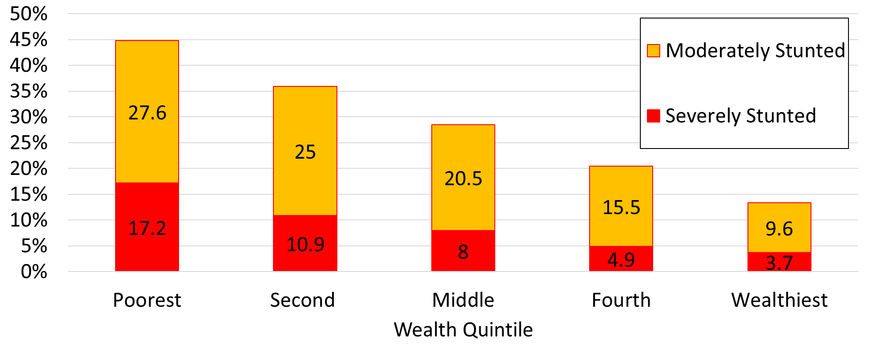 **Figure 4**. Prevalence of stunting among 0-59 months old children by income quintile, 2015

# **What drives stunting in the Philippines?**

It is known that malnutrition results from the interplay of various factors with poor dietary intake, physical inactivity and disease as immediate causes and underpinning these immediate causes are underlying ones related to household food security, health services and environmental quality and care practices. These factors are further affected by basic causes related to formal and informal institutions, economic structure, and potential resources.

An understanding of key factors will help in identifying the appropriate interventions to reduce stunting. The factors that drive stunting are many and are interlinked and likely to be cyclical, i.e., mothers who are short tend to bear stunted children. [See Figure 5]

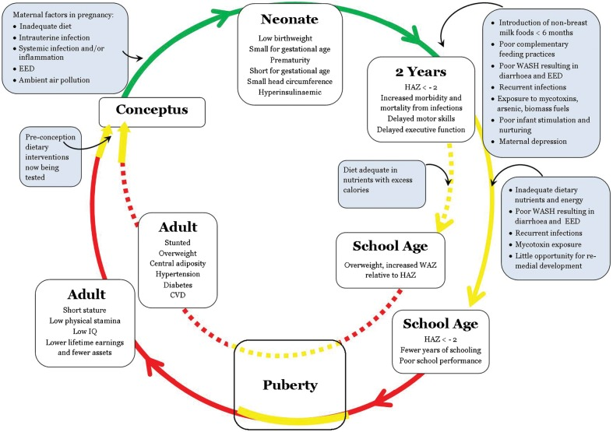**Figure 5.** Conceptual framework of stunting that is cyclical

Source: Prendergast, A.J. and Humphrey J.H.

For the Philippines, what are the factors that lead to the high prevalence of stunting and the lack of progress in the last 15 years?

Agdeppa, et. al., determined the factors that drive stunting by following the 0-23 months old children who were included in the 2003 national nutrition surveys and were also included in the 2011 survey [15]. The study showed that stunting increased more than double as the children reached 8-9 years into middle childhood. About 22.1% became stunted later while 13.1% remained stunted and only 4.1% became normal. The factors that drove the children into stunting later were categorized as individual factors and household factors. Individual factors that were found to be significant were those stunted at an older age onset of stunting, underweight and with less than 2 years birth interval. For the household factors, stunting is more likely if the child belongs to a family that has more than 5 dependents and higher number of under-fives in the family. Those children living in shanties pushed them from being normal to stunting. The study, however, did not find any significant factor that moved children out of stunting.

The World Bank Group study on the drivers of stunting in the Philippines released in June 2020 provide useful insight to understand the problem [14, 16]. The study analyzed data from the 2015 National Nutrition Survey. What appears to be the drivers of stunting based on the detailed analysis are affected by factors before birth and factors after birth. Stunting is likely to happen with poor maternal health and nutrition which is likely to result in low birth weight babies and small for gestational age baby. The risk is higher with adolescent pregnancy which is increasing in the country. After birth factors include poor dietary diversity of children that is driven by both feeding practices and high prices of nutrition foods. Low consumption of meat, eggs and milk is associated with high levels of stunting. Most of stunted children belong to families that are moderately or severely food insecure which would explain the poor diet diversity. Infants who do not have access to clean drinking water and during the first six months are raised by single mothers have higher risk of stunting.

# **What do we aim for in stunting?**

It is interesting to note that previous national plans of action for nutrition, particularly for 1993-1998 and 1999-2004, have not targeted reduction in stunting but rather targeted reduction in protein-energy malnutrition with a focus on reducing the prevalence of underweight children. The reduction in stunting became a target in the PPAN for the period 2005-2010 in which the target was a reduction from 29.0% in 2005 to 25.4% in 2010 among stunted children 0-5 years old. In the succeeding PPAN 2011-2016, reduction in stunted under-five children was targeted from 32.3% in 2008 (as baseline) to 20.9% in 2016.

The PPAN 2017-2022 targets a reduction of stunting prevalence from 33.4% in 2015 to 21.4% in 2022. The target is based on the World Health Assembly Global Nutrition Target by 2025 to have a 40% reduction in the number of stunted children under five years. This is consistent with the 2030 Sustainable Development Goals specifically, *Goal 2* or *Zero Hunger* which aims to end hunger, achieve food security and improved nutrition and promote sustainable agriculture with one of its targets being “by 2030, end all forms of malnutrition, including achieving, by 2025, the internationally agreed targets on stunting and wasting in children under 5 years of age, and address nutritional needs of adolescent girls, pregnant and lactating women and older persons.”

To achieve this target, the PPAN identified the provinces (Table 1) with the highest stunting rates as priority with an assumption that a 50% reduction in stunting in these areas should be able to reach the targeted reduction in terms of magnitude, i.e., number of children who are not stunted rather than percent of under-five children who are stunted. These provinces are prioritized for mobilization of local government units.

**Table 1.** PPAN 2017-2022 Focus Areas Based on Stunting Prevalence

|  |  |  |  |
| --- | --- | --- | --- |
| Region | Province | Region | Province |
| 2 | Quirino | 8 | Biliran, Eastern Samar, Northern Samar, Samar |
| CAR | Abra, Mt. Province, Ifugao | 9 | Zamboanga del Norte, Zamboanga Sibugay |
| 3 | Aurora | 10 | Bukidnon, Lanao del Norte |
| 4B | Occidental Mindoro, Palawan, Romblon | 12 | North Cotabato, Sarangani, South Cotabato, Sultan Kudarat |
| 5 | Albay, Masbate, Camarines Norte, Camarines Sur, Catanduanes | Caraga | Agusan del Sur |
| 6 | Aklan, Antique, Negros Occidental, Capiz | BARMM | Lanao del Sur, Maguindanao, Sulu, Tawi-Tawi |
| 7 | Negros Oriental, Bohol |  |  |

However, the target provinces have been updated and the new priority provinces (Table 2) have been aligned with the Human Development and Poverty Reduction Cluster (HDPRC) Priority Provinces. These provinces have been identified with one of the criteria being the prevalence of stunting.

**Table 2.** HDPRC Priority Provinces

| **Level of Priority** | **Luzon** | **Visayas** | **Mindanao** |
| --- | --- | --- | --- |
| First Priority | Camarines Sur | Negros Occidental  Negros Oriental | Bukidnon  North Cotabato  South Cotabato  Zamboanga del Norte |
| Second Priority  (2021) – focused on nutrition) | Catanduanes  Masbate | Eastern Samar  Northern Samar  Western Samar | Lanao del Norte  Sarangani  Sultan Kudarat  Agusan del Sur  Maguindanao  Lanao del Sur  Sulu |
| Second Priority (2021) – focused on teenage pregnancy | Pangasinan  Nueva Ecija  Quezon | Iloilo  Cebu  Leyte | Zamboanga del Sur  Davao del Sur |
| Third Priority | Apayao  Sorsogon | Siquijor | Davao Occidental  Surigao del Sur |

# **What have been done to address stunting?**

The country is making some dent in its efforts to reduce stunting. The Philippine Plan of Action for Nutrition 2017-2022 provides the overall framework to address malnutrition including stunting and its underlying factors (Refer to Figure 6). The NNC Governing Board which approved the PPAN set-out ambitious target for stunting reduction of 20%, i.e., from 33.4% in 2015 to 21.4% in 2022. There has been a reduction in stunting in 2018 at 30.3%.

The PPAN is taking off with the support of members of the NNC Governing Board. For example, the Department of the Interior and Local Government (DILG) has issued Memorandum Circular No. 2018-42 dated 26 March 2018 enjoining LGUs to prioritize the allocation of local funds for its local nutrition action plans that is formulated in accordance with the PPAN 2017-2022. To support this issuance, the Department of Budget and Management (DBM) issued Local Budget Circular 2019-78 dated 15 May 2019 and Local Budget Memo Circular 2020-80 dated 18 May 2020 pertaining to the preparation of the 2020 and 2021 annual budgets of LGUs wherein local chief executives are required to prepare and submit as part of the proposed budgets the local nutrition action plans. These issuances recognize the crucial role of LGUs in addressing stunting and other nutritional problems as part of their mandate. Such actions are part of the PPAN’s strategy to mobilize LGUs for increased investment in nutrition.

The National Nutrition Council has organized the Scaling Up Nutrition Movement in the country with the mobilization of various stakeholders including civil society, academe, business sector and the UN network.

**Figure 6.** PPAN 2017-2022 Program Framework

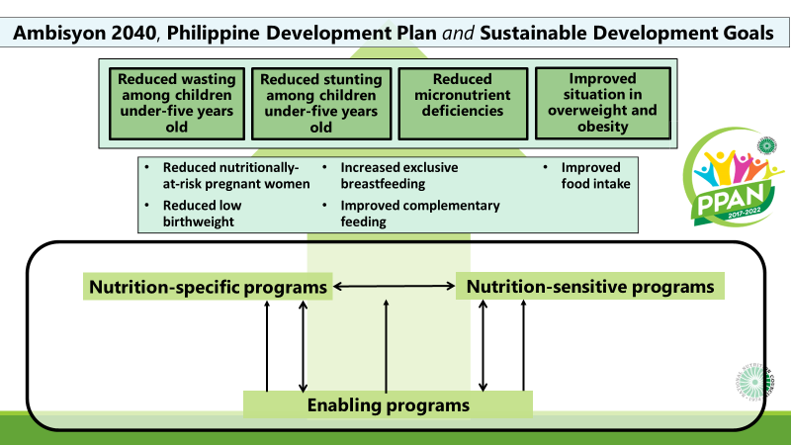Source: National Nutrition Council.

One of the strategic thrusts of PPAN 2017-2022 is the focus on the First 1000 Days of Life. The PPAN gives priority to the nutritionally vulnerable (pregnant and lactating women, infants, and young children 0-23 months old) and those who are already malnourished, among others.

PPAN 2017-2022 involves the implementation of nutrition-specific programs to address the immediate causes of malnutrition, and nutrition-sensitive programs to address the underlying and basic causes.

Interventions recommended by the PPAN include the following:

1. Maternity protection and improving capacities of workplaces on breastfeeding
2. Establishing lactation stations in non-health establishments
3. Nutrition promotion for behavior change
4. Supplementary feeding of pregnant women and children 6-23 months, 24-59 months, and school children
5. Iron-folic acid and other micronutrients supplementation of pregnant women, as well as consumption of fortified food items
6. Prevention and management of infections and diarrhea
7. Regular growth monitoring of weight and height.

Translating the PPAN directions into concrete programs, the NNC led the implementation of the multi-sectoral and multi-level Early Childhood Care and Development in the First 1000 Days Intervention Package (ECCD F1K IP). It aims to reduce stunting by delivering an integrated package of health, nutrition, early education, and social services. Below are the key services of the program by life stage.

*Pregnancy*

1. Dietary supplementation
2. Nutrition counseling on diet of pregnant women
3. Empowering women and their partners on preparation of birth plans (facility-based delivery, attended by health professional, breastfeeding and rooming-in), family planning information

*Birth and delivery*

1. Provision of essential intrapartum and newborn care/ Mother-Baby Friendly Hospital Initiative Services
2. Breastfeeding initiation and breastfeeding counseling support
3. Initiation of breastfeeding and rooming-in
4. Linkage with community health and nutrition workers including IYCF support (including lactation management and breastfeeding support)
5. Exclusive breastfeeding and breastfeeding support group

*0-11 months*

1. Iron supplementation for preterm and low birth weight infants
2. Vitamin A supplementation (6 months)

*1-5 months*

1. Exclusive breastfeeding and breastfeeding support in home, community, and workplace
2. Nutrition support for nutritionally-at-risk mothers
3. Iron supplementation of anemic lactating women
4. Integrated Management of Childhood Illness (IMCI)
5. Oral rehydration salt solution with oral zinc
6. Management of severe wasting (low weight-for-height)

*6-23 months*

1. Complementary feeding with continued and sustained breastfeeding
2. Vitamin A supplementation
3. Home food fortification with multiple micronutrient powder
4. Growth and Milestone Development Assessment, Monitoring and Promotion
5. Integrated Management of Childhood Illness
6. Management of acute and severe wasting (low weight-for-height)
7. Water, sanitation, hygiene, and deworming
8. Psychosocial stimulation especially during feeding time
9. Provision of appropriate nutrition-sensitive interventions such as home kitchen gardening, income generating opportunities, conditional cash transfer, and water and sanitation and hygiene

There are other programming models that have been implemented under the First 1000 Days strategy by LGUs such as the Q1K of Quezon Province, non-government organizations such as Save the Children Philippines and World Vision. The number of LGUs with initiatives on the First 1000 Days in increasing. However, to achieve the targets, more efforts are needed especially among local government units.

Legislative measures

There are also several key legislations that were enacted by Congress to provide an enabling environment for better nutrition. These include **Republic Act 11148** or the *Kalusugan at Nutrisyon ng Mag-Nanay* Act in November 2018. This law supports scaling up nutrition intervention programs in the First 1000 days of a child’s life, and allocates resources in a sustainable manner to improve the nutritional status, and address malnutrition of infants and young children from 0-2 years of age, adolescent females, pregnant and lactating women. The law also strengthens the enforcement of **Executive Order 51** or the Philippine Milk Code and **Republic Act 10028** or the Expanded Breastfeeding Promotion Act. The Milk Code regulates the marketing and distribution of breastmilk substitutes, breastmilk supplements and related products so as not to undermine breastfeeding. RA 10028, on the other hand, requires all health and non-health facilities, establishments, and institutions to establish milk banks, lactation stations, and provide lactation breaks to lactating mothers in the workplace.

Another law that will support nutrition in the first 1000 days **is Republic Act 11210** or the Expanded Maternity Leave Act which extends paid maternity leave from 60 to 105 days. This addresses the concern that mothers stop breastfeeding when they return to work. With this law, working mothers are given more time and resources to recover from pregnancy and childbirth and to care for the baby.

Enacted on 20 June 2018, **Republic Act 11037** or the *Masustansyang Pagkain para sa Batang Pilipino* Act institutionalizes a national feeding program for undernourished children in public day care, kindergarten, and elementary schools to address hunger and undernutrition among children. The feeding program is designed to include complementary components such as the *Gulayan sa Paaralan* program, health assessment and services, water, sanitation and hygiene and nutrition education.

Other interventions

Nutrition specific programs are complemented with nutrition-sensitive programs. These include programs of different sectors that are tweaked to results to positive outcome in nutrition.

The *Pantawid Pamilya Pilipino* Program or 4Ps, a conditional cash transfer program began in 2008, was found to significantly reduce severe stunting in children aged 6-36 months as well as improve parenting practices including children’s intake of protein-rich foods and care-seeking behaviors based on a study conducted in 2011 [17] . The study cited that among the conditional cash transfer programs in the world, the 4Ps was one of few such programs that made a significant impact on stunting. Republic Act 11310 institutionalizes the program as the national poverty reduction strategy and human capital investment and includes addressing malnutrition and hunger as one of its objectives.

It must be noted that the interventions mentioned here are not exhaustive.

# **What can stakeholders do to support efforts to reduce stunting?**

Based on the analysis of the drivers of stunting, significant reduction in stunting would occur when there are improvements in the health and nutrition of pregnant women and adolescents and in food security and diversity. Pregnant adolescents and women should have access to nutrition and health services to improve birth outcomes as well as responsible parenting to manage fertility. Children must also have access to a variety of foods especially those that are rich in protein such as meat, fish, poultry, and eggs. This will entail improving access and availability of nutritious food. Attention should also be given to ensure that households have access to clean drinking water supply and sanitation and wastewater systems.

Here are some key actions to support reduction in stunting:

# Mothers and family members

1. Bring your 0-23 months old child to the health center every month to monitor weight and height; for older children, bring them every three months. A child needs to reach a height of 80 centimeters when he or she is 2 years old and about 109-110 centimeters at 5 years of age.
2. Breastfeed your baby in the first 6 months then starting at 6 months while continuing breastfeeding, give a variety of food that includes animal-source food (meat, fish, poultry, eggs)
3. Practice good hygiene such as handwashing to prevent disease and get proper medical care when your child is sick
4. Participate in nutrition and health education classes
5. Prevent teen pregnancy
6. Provide support and care to single mothers
7. Start and maintain a food garden including raising small animals as source of protein

# Communities

1. Establish designated lactation areas to protect children and women
2. Improve access to nutritious foods through community food gardens
3. Raise awareness about importance of proper nutrition, proper hygiene, and sanitation during the first 1000 days
4. Strengthen implementation of policies related to child nutrition
5. Encourage active involvement of community members in ECCD programs
6. Promote community development efforts and develop initiatives that improve the quality of life for young children and families

# Government

* 1. Include nutrition actions with corresponding budget in annual investment plan for 2021 and onwards
  2. Update sectoral programs to have an impact on nutrition including:

1. The *Pantawid Pamilya Pilipino* Program can impact on stunting with the inclusion of families with pregnant adolescents and women and children 0-24 months. The Family Development Sessions can also contribute with the inclusion of nutrition topics particularly on the first 1000 days.
2. Agriculture sector to improve farmers’ incomes to improve their access to nutritious food and support the establishment of food gardens.
3. Local government to formulate and implement local nutrition action plans to align with the PPAN 2017-2022
4. Improve access and delivery of maternal and child health and nutrition interventions by scaling-up the First 1000 Days strategy as provided in RA 11148 (*Kalusugan at Nutrisyon ng Mag-Nanay* Act)
5. Use the Operation *Timbang* Plus results to determine children 0-23 months old with growth faltering for interventions such as dietary supplementation; conduct screening of pregnant women for nutrition risk and provide dietary supplementation in the third trimester

# Academe

* + 1. Conduct webinars, online fora and other activities to increase awareness on stunting prevention
    2. Increase engagement of students through online modules and quizzes
    3. Conduct online video-making, poster-making, slogan-making competitions to encourage participation of students
    4. Mobilize school-based organizations to launch their own initiatives
    5. Explore scientific researches related to stunting

# NGOs, civic groups, civil society, and private sector

* + 1. Support efforts to prevent stunting by helping scale-up actions in the first 1000 days
    2. Develop materials related to prevention of stunting and utilize virtual platforms for proper information dissemination
    3. Work with government to fill the gap in terms of service delivery
    4. Integrate improved water, sanitation, and hygiene (WASH) in community-based interventions to protect children from subclinical infections
    5. Join the Scaling-Up Nutrition Movement alliances (civil society, and business network)

# **How does the COVID-19 pandemic affect stunting reduction efforts?**

The COVID-19 pandemic will likely impact nutrition through several ways. Varying levels of community quarantine will disrupt livelihood and employment of people and limit their access to safe and nutritious foods. Already, there has been a record increase in reported hunger incidence at 16.7% in May 2020 which is double that the 8.8% reported in December 2019. [18] The health system is focused on responding to the health emergency and will affect delivery of nutrition and related services. Food systems are likely to be disrupted reducing access of people to food. While there are social protection programs, the delivery may be slowed or hampered. Thus, it is important that during the emergency, nutrition must be protected and ensured.

With increasing food insecurity and reduced access to services, the existing malnutrition problem may worsen.

The following are key recommendations to support nutrition in the time of COVID-19.

1. **Good nutrition is key to build immunity, protect against illness and infection and support recovery.** Include in Covid-19 prevention efforts to preserve and promote proper nutrition, including breastfeeding and appropriate complementary feeding practices among children 0-23 months to build resilience of individuals and communities.
2. **Ensure food and nutrition security** to prevent a food and malnutrition crisis. Prolonged hunger can lead to malnutrition which will have long-term effects especially among pregnant women and children 0-23 months.
3. Ensure that nutrition and related interventions especially in the **First 1000 Days are continued** and delivered in a safe and sustained manner.

The Nutrition Cluster under the Health Emergency Response Cluster through the National Nutrition Council issued advisories to protect and promote nutrition as guide for responders especially LGUs. The Department of Health has issuances to ensure the continuity of health and nutrition services while maintaining health standards to prevent the spread of the COVID-19.

# **What are suggested activities to support the Nutrition Month campaign?**

Here are some ways to support the Nutrition Month campaign while adhering to health standards to prevent the spread of COVID-19:

* 1. Review organization plans and programs and tweak for nutrition outcomes.
  2. Disseminate about Nutrition Month through streamers, websites and social media platforms.
  3. Conduct virtual seminars for clients and employees.
  4. Participate in activities related to Nutrition Month celebration at the national, regional or local level.
  5. Provide services related to stunting prevention.
  6. Conduct Nutrition Month activities related to the theme such as cooking demonstrations on complementary food for mothers and caregivers, forum and seminars for parents; activities for adolescents to prevent teen pregnancy.

Check the NNC website and Facebook page for more information as well as the First 1000 Days PH Facebook page.

# **Citations**

[1] Save the Children. “Sizing up: The Stunting and Child Malnutrition Problem in the Philippines”. Accessed on 10 June from <https://resourcecentre.savethechildren.net/node/13449/pdf/save-the-children-lahatdapat-sizing-up-the-stunting-and-child-malnutrition-problem-in-the-philippines-report-september-2015.pdf>

[2] Measure Evaluation. Indicator Compendium for Reproductive Maternal and Newborn Child and Adolescent Health. Accessed on 12 June 2020 from <https://www.measureevaluation.org/rbf/indicator-collections/health-outcome-impact-indicators/children-under-5-years-who-are-stunted>

[3] WHO. Global Nutrition Targets 2025: Stunting policy brief. Retrieved on 9 June 2020. [https://www.who.int/nutrition/publications/globaltargets2025_policybrief_stunting/en](https://www.who.int/nutrition/publications/globaltargets2025_policybrief_stunting/en/)

[4] Michelle A. Mendez, Linda S. Adair; Severity and Timing of Stunting in the First Two Years of Life Affect Performance on Cognitive Tests in Late Childhood, The Journal of Nutrition, Volume 129, Issue 8, 1 August 1999, Pages 1555–1562, <https://doi.org/10.1093/jn/129.8.1555>

[5]The effects of stunting retrieved on 9 June 2020 from <https://www.powerofnutrition.org/the-impact-of-stunting/>

[6] Dewey, K.G and Begum K. Long-term consequences of stunting in life. Accessed on 25 June on <https://onlinelibrary.wiley.com/doi/full/10.1111/j.1740-8709.2011.00349.x>

[7] Prendergast, A.J. and Humphrey J.H. The stunting syndrome in developing countries. Paediatrics and International Child Health Volume 34, 2014 - Issue 4: Nutrition and malnutrition in low- and middle-income countries. Accessed on 26 June 2020 from https://www.tandfonline.com/doi/full/10.1179/2046905514Y.0000000158

[8] WHA *Global Nutrition Targets 2025*, WHO (World Health Organization), Editor.

[9] Galasso, E.W., Adam., *The aggregate income losses from childhood stunting and the returns to a nutrition intervention aimed at reducing stunting.* World Bank Group. Policy Research working paper., 2018.

[10] NCD Risk Factor Collaboration. Accessed on 22 June 2020 from <http://ncdrisc.org/height-mean-distribution.html>

[11] PowerPoint presentation “Chronic undernutrition in the Philippines: The role of knowledge, beliefs, & perceptions” Preliminary Report. Presented during the NNC Multisectoral Actions to Prevent Stunting on 02 October 2019.

[12] Food and Nutrition Research Institute. 2018 National Nutrition Survey.

[13] Food and Nutrition Research Institute. The 6th National Nutrition Surveys: Initial Results.

[14] Demombynes, Gabriel. PowerPoint Presentation “Achieving Zero Hunger and   
Healthy Growth for All Filipinos: A Preview of Main Findings”. Presented during the NNC Information Sharing Session on 16 June 2020.

[15] Angeles-Agdeppa, I., Gayya-Amita, P and Capanzana, M. Drivers of Stunting Among 0-23 Months Old Filipino Children Included in the 2003 and 2011 National Nutrition Survey. Accessed on 15 June from <http://www.lifescienceglobal.com/pms/index.php/ijchn/article/view/6091>

[16] Capanzana, M., Demombynes, G. and Gubbins, P. “Why Are So Many Children Stunted in the Philippines?”. Policy Research Working Paper 9294. World Bank Group – Health, Nutrition and Population Global Practice. Accessed from <http://www.worldbank.org/prwp>

[17] Eeshani Kandpal, Harold Alderman, Jed Friedman, Deon Filmer, Junko Onishi, Jorge Avalos. A Conditional Cash Transfer Program in the Philippines Reduces Severe Stunting. The Journal of Nutrition, Volume 146, Issue 9, September 2016, Pages 1793–1800, https://doi.org/10.3945/jn.116.233684 Accessed on 26 June from <https://academic.oup.com/jn/article/146/9/1793/4584896>

[18] Social Weather Stations. Covid-19 Mobile Phone Survey Report No. 2: Hunger among families doubles to 16.7%. Press release posted 21 May 2020. Accessed from <http://www.sws.org.ph/swsmain/generalArtclSrchPage/?page=1&srchprm=&arttyp=6&stdtrng=&endtrng=&swityp=>.